Your Project Title Here

# Group Member Names

Contents

Group Member Names 1

List of Figures 3

Project Team 5

Introduction 6

Project Requirements 6

Project Plan 7

Spider Diagram 7

Website Design 8

Website Design v0.2 9

Final Website Design 10

Website Structure 11

Database Structure 12

Project Components 15

[Payment] – [Sabaa Fatani] 15

[Loyalty Scheme] – [Sabaa Fatani] 15

Project Documentation 15

[Project Role] – [Name of the Person Responsible] 16

Group Activities 16

ConclusionReferences 17

Appendix A 19

# List of Figures

List of figuresAbstract

This section should describe your project detailing the functionality you have achieved and the motivation behind the project.

The motivation behind the project is to provide a means of purchasing products and services for customers, with the aim of making the process easier for the user. Which brought us to the conclusion of designing a Supermarket based website. The functionality of the application must enable the user to select a product and place it in the basket, in which the user would later proceed with check out.

# Project Team

This section should present the project team, their specific roles within the team and their responsibilities in terms of the software component they were responsible for the development of.

The team is made up of five members each with their own roles and responsibilities. The members are Abdala, Akber, Sabaa, Subdoh and David.

Abdala was responsible for keeping a log of meetings as well as a primary researcher for the team in terms of resources. In addition to this, he was also responsible for the registration form and login page in terms of the core development of the project.

Sabaa was responsible for the database structure and website structure, in terms of the core design. Furthermore, he was responsible for the link between the database and the website, in terms of how the website would extract the content from the database and display it on the website.

Akber’s role was team leader, and as such he was responsible for keeping track of the team members progress in terms of whether or not their carrying out their assigned tasks. Simply put, the team leader is what unifies the team, as well as a checkpoint to ensure that the tasks are completed by the set deadline.

# Introduction

The software we have created is an application which runs in a web browser it is a website. Designed to be used as an online checkout tool for a super market e.g. where buyers must register, then top up their account via credit card system. Then the buyer can browse products and choose to add specific quantities to the cart which will be showing the total as they go along. A buyer also has been shown to use product promotions and multibuy offers such as promo codes etc. when they reach the checkout they can see the total and see any discounts they receive and then pay for the items.

The software consists of four components, which are Marketing, Payment, Supplier and loyalty Scheme.

We achieved a fully functional website where a user can register top up their account, then go browsing through the different things that are for sale from a range of food to electronics, they can add the products to the cart and the cart will total up and show the total price in which they can buy the product.

The supplier side can log on with the special account and can view product quantity real time and can therefor order more stock to keep the supply running.

Marketing can check receipts and see what things have been purchased and see what things have not been sold, so they can put an offer on the main display page.

There is a contact page, user can see previous transactions in the form of receipts. We have also implanted the use of a loyalty scheme, where when each pound you spend you get points, and when the accumulate you can use it against the shopping.

The process we followed in the development of this website, firstly we choose the roles and who would carry out what task . Then we distributed the core development amongst out selves

the process you have followed.

It is important that you distinguish among different components such as the Core, Payment, Supplier interface etc. at this stage as this will then help you keep the rest of the document concise and structured.

# Project Requirements

Requirements of the overall project. This can be obtained from the case study provided as part of the assessment as well as other methods such as brainstorming and interviewing stakeholders. It is envisaged to have been gathered by the project manager for the overall project.

# Project Plan

### Spider Diagram

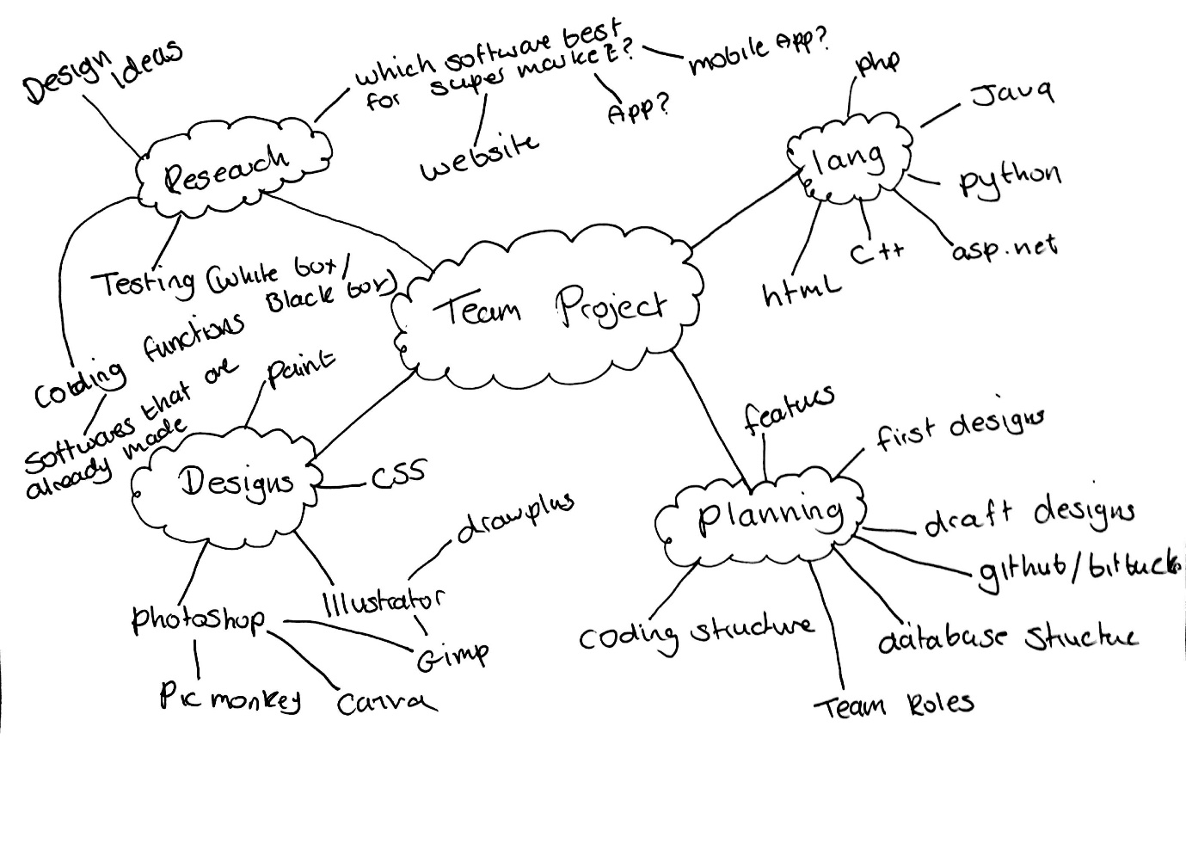

### Website Design

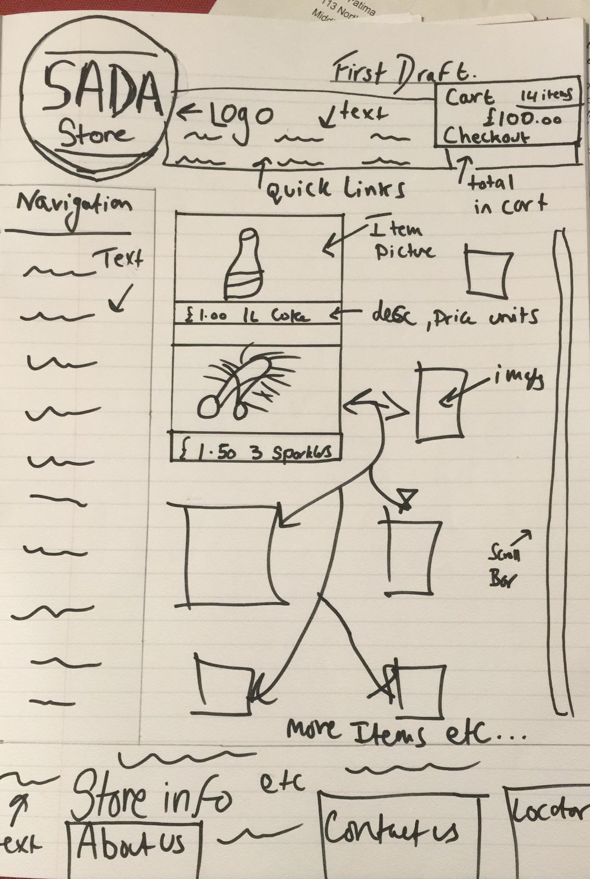

### Website Design v0.2

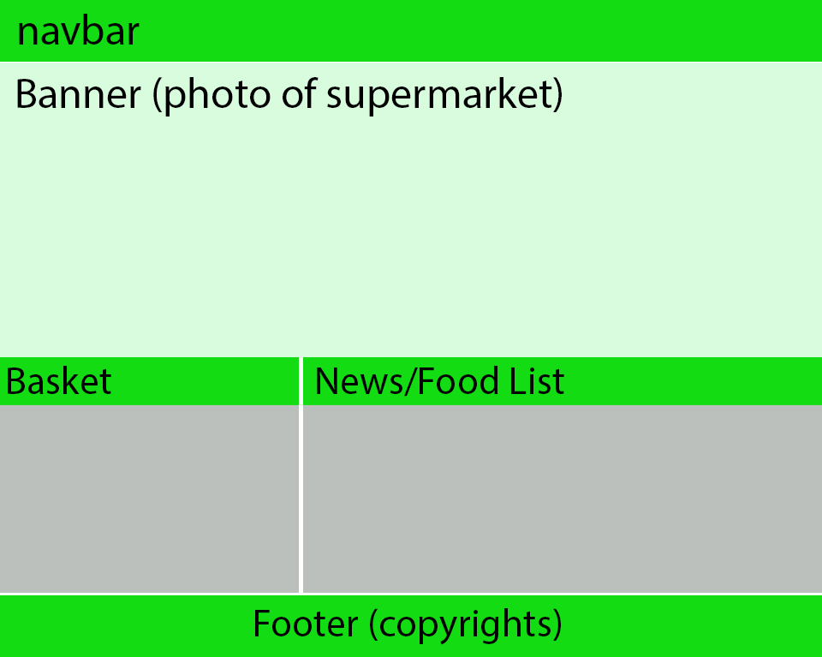

### Final Website Design

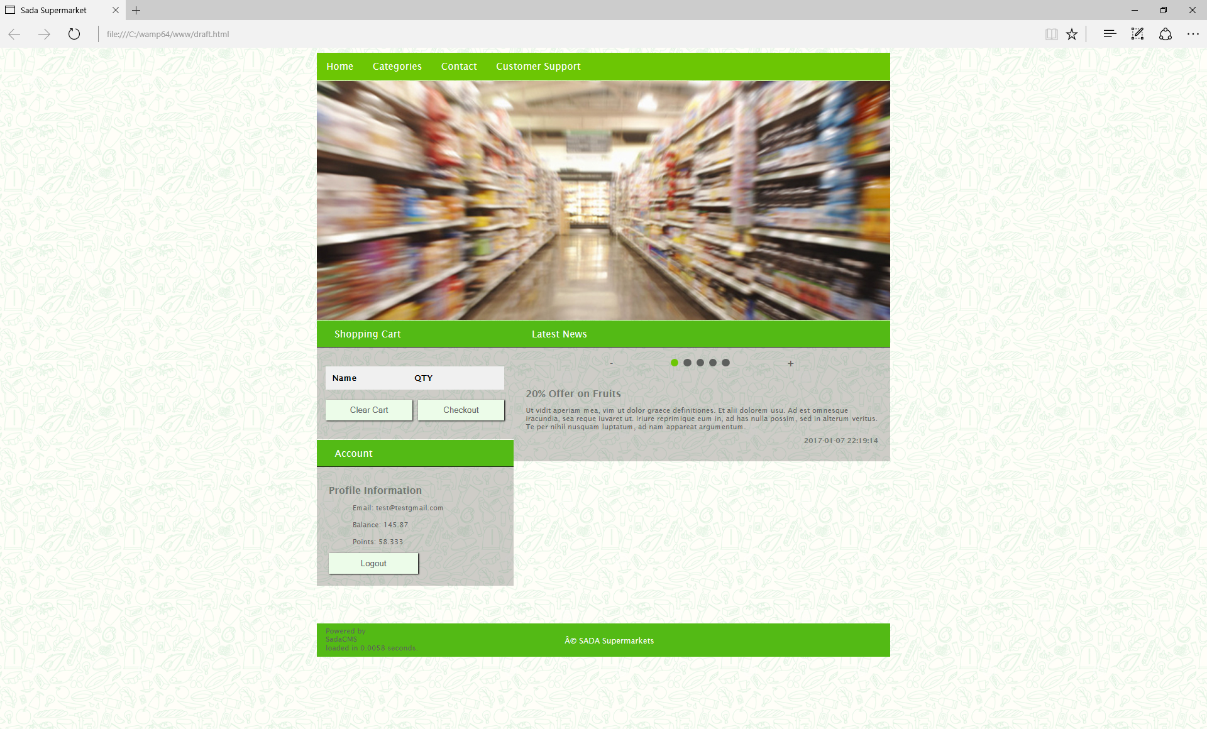

### Website Structure

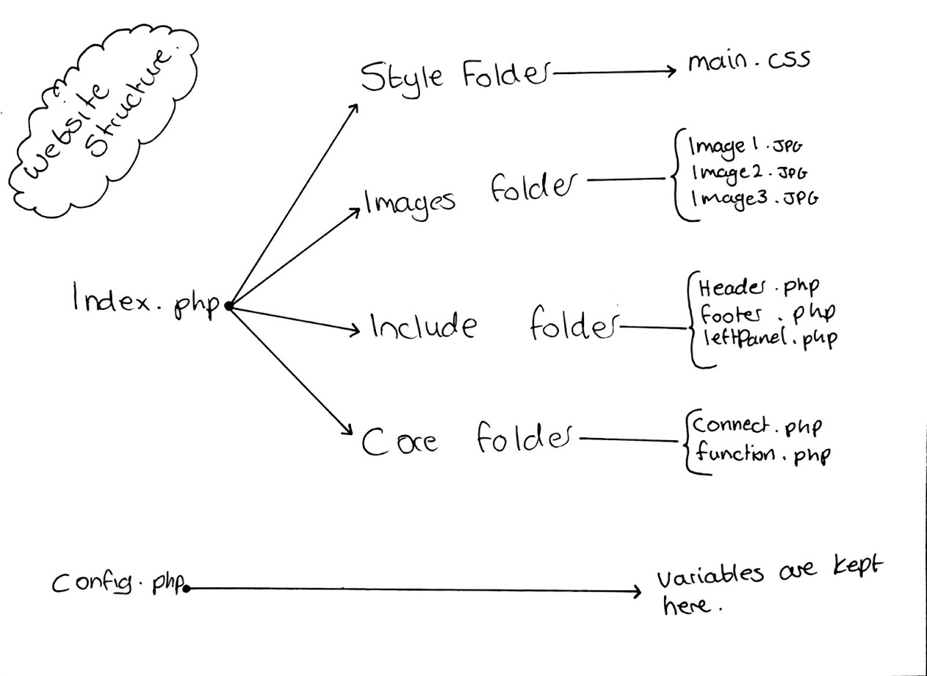

### Database Structure

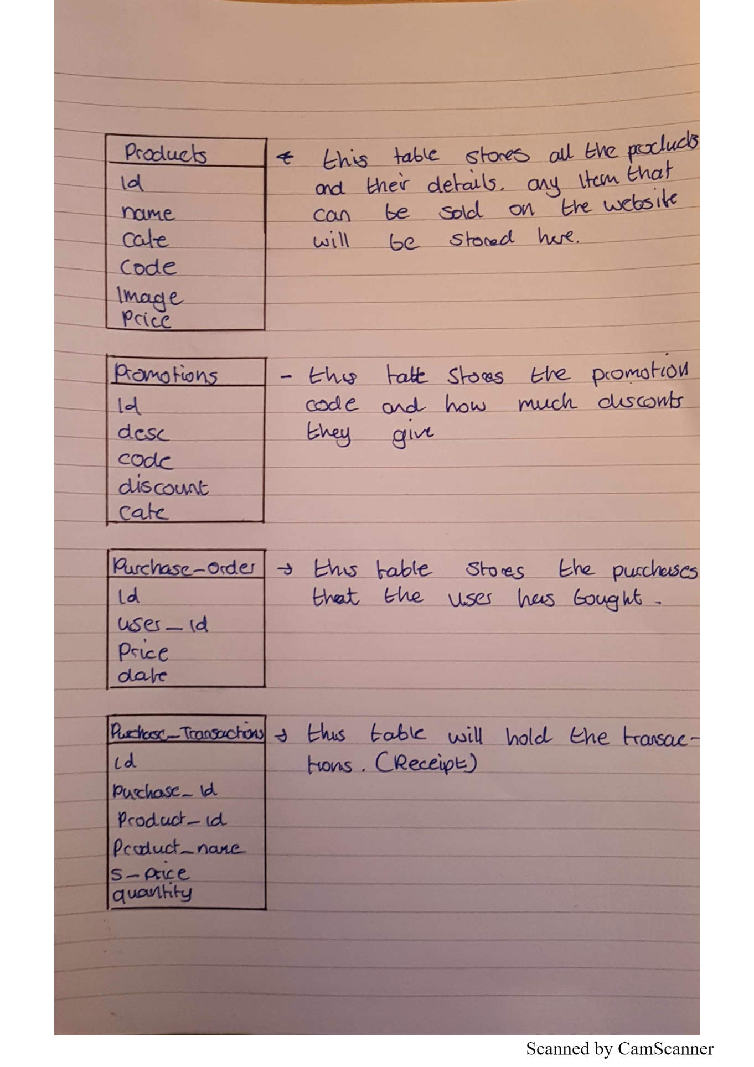

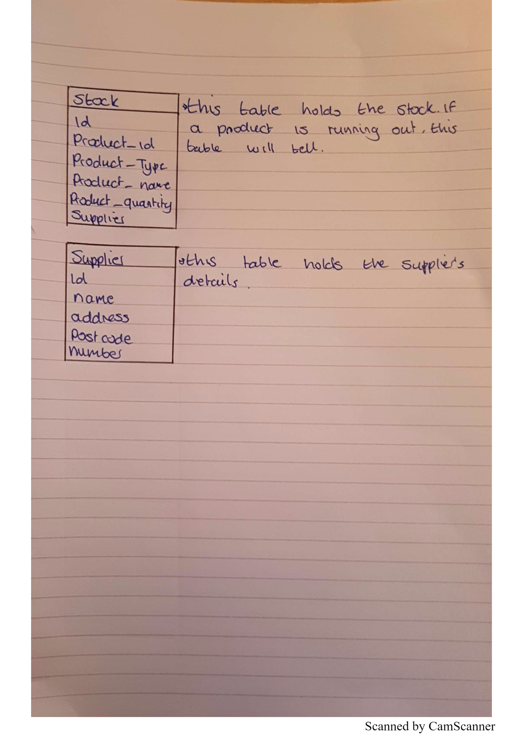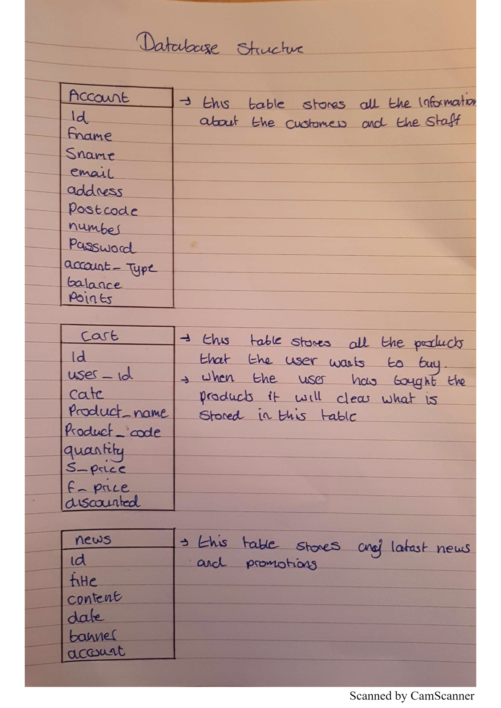

# Project Components

Describe different project components such as the Core, the payment, the marketing, the loyalty scheme and the supplier interface components. The section should start with naming different components you have developed followed by a detailed description of each component in a subsection below.

The Core was a group task therefore you are not required to name a group member for this.

## [Payment] – [Sabaa Fatani]

Should include the following:

* Brief description of the component
* Requirements for the component
* Plan/schedule for the component development
* Technical documentation (at least one use case, class diagram and activity diagram)
* Functionality achieved (you can include screen shots from the software implementation)
* Risk Register for the component
* Test plan for the component

## [Loyalty Scheme] – [Sabaa Fatani]

Should include the following:

* Brief description of the component
* Requirements for the component
* Plan/schedule for the component development
* Technical documentation (at least one use case, class diagram and activity diagram)
* Functionality achieved (you can include screen shots from the software implementation)
* Risk Register for the component
* Test plan for the component

## [Supplier] – [Akber]

Should include the following:

* Brief description of the component
* Requirements for the component
* Plan/schedule for the component development
* Technical documentation (at least one use case, class diagram and activity diagram)
* Functionality achieved (you can include screen shots from the software implementation)
* Risk Register for the component
* Test plan for the component

## [Marketing] – [Abdol]

Should include the following:

* Brief description of the component
* Requirements for the component
* Plan/schedule for the component development
* Technical documentation (at least one use case, class diagram and activity diagram)
* Functionality achieved (you can include screen shots from the software implementation)
* Risk Register for the component
* Test plan for the component

# Project Documentation

This section should include documentation produced by different roles within the project team.

## [Project Role] – [Name of the Person Responsible]

Should include the following:

* Brief description of the role and its responsibilities
* Documentation produced by individual role. This will depend upon the roles adopted within your group. Examples of such documentation can include Risk Register, Test Plans, Tech./Design Documentation (Use Case, Activity Diagram, Sequence Diagram ) for the core.

*If you have any confusion about what should be included in this section as part of your role, you can discuss this with me.*

# Group Activities

This section is expected to include the group activities you conducted to accomplish this project. These can include:

Group activities consisted of firstly creating a WhatsApp group chat, this was partially useful as this was the first main point of contact to raise any concerns or general talk. We could all get notifications and can communicate freely from where ever.

Meetings would also be done on Tuesdays between the group members to show and discuss any problems or ideas they had.

Github was the platform we choose to share all media resources and work completes and various documents.

# ConclusionReferences

List of References

# Appendix A

User Manual